**Product Review** Appendix [#]

I downloaded the 5 most downloaded FPL assistant apps on the play store and tested them all. This was to see what other app provided users and to see the overall quality of other apps in the field. A full write up can be found in the appendix but here I will discuss my findings.

The first app being Fantasy Football Fix. After using this app I found the app didn't offer much in the sense of helping them with playing the game but instead live stats. The official FPL app/website takes a while to update leader boards so this app offers your live points and where you rank globally. A few other features such as a blog and who’s price is expected to drop or rise. Overall the app doesn’t exactly help the player improve or influence a player to make decisions, more just an app to see live scores of their team.

The second and third apps were called Fantasy Manager and Fantasy Football Manager. These apps had the same fundamental problem of not offering anything new. Both apps from my perspective we just re-skinned versions of the official app. Neither offered any additional tools or feature but instead just tried to change the layout/UI of the existing app.

Next was an app called Fantasy Football Assistant. This was my favorite app out off all the ones I looked at. Simple UI, useful features and offers nothing but tools that the official app doesn’t offer. The features included the top 5 projected players for each position, a prediction of the highest scoring team this week (with and without a budget) and the fixtures this coming week. The idea of having a prediction of the best team with and without a budget I think is a really great idea.

Lastly was the FFHub app. This is known in the FPL community as one of the best resources when wanting to improve your chance at doing well. Its has a lot of useful features and a lot of stat analysis features. The biggest drawback is that almost all the features are locked behind this paywall. Overall seems to offer some great features and tools like the player comparison tool or the many articles they write on a regular basis but again the paywall is a big turn off.

I found this research really useful to see what other people had done to assist others at the game. I found that 2 of them didn't actually do anything different, they showed the same things as the official app and offered no features you could do outside it. The main features that appeared often that I liked were:

- showing the fixtures for the week (which the official app already does) but id like to make it so when you click a fixture that it shows the predicted line up

- Being able to compare players (not behind a pay wall)

- An algorithm that predicts the highest scoring team (with and without a budget)

I also really like the idea of having blog/articles but I want the app to be automated (in the sense of all the features to run automatically with me having to do anything). Possibly look into an API to supply some articles as an option if I have time

|  |  |
| --- | --- |
| App Name |  |
|  |  |
|  |  |
|  |  |

**Predicted line-ups**

Knowing who will start in a premier league game is very important for different reasons. It’s not as simple as more playing time means more chance of doing something (although this is important). It’s due to the scoring system in FPL. Each player get one point for playing in a game and a second for playing 60+ minutes. Lets look at goalkeepers and defenders. These types of players are obviously defensive minded so their goal in a game is to not concede goals as they get points for not letting it happen and lose points if they do. They only get clean sheet points from playing 60+ minutes and not conceding. So it’s important when picking defenders to make sure they are going to start so they’re more likely to get these points as they cannot get this unless they then come on before the 30th minute. This is highly unlikely as first half substitutes are very rare and defenders are the least substituted players (next to Gks) [#]. Therefore it’s critical that you pick defenders who will start the game. Midfielders and forwards also benefit from starting games rather then coming on as a sub. Both types of players for the most points from scoring goals.

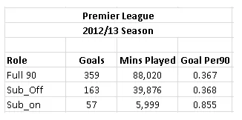

Figure #: https://statsbomb.com/2014/01/smart-use-of-substitutes-can-make-a-difference/

Here it shows players that play a full 90 minutes or even start the game but later get subbed off score more goals than players that get subbed on. So knowing who starts games can be vital to picking players for your team. (put survey data here showing people want it? Or is that later?)

**Best Team Prediction Algorithm (justifying why I'm doing it this way)**

Why not to base it solely on real life ability, the points system/rules, my approach

**Why look at the stats?**

One of the biggest mistakes that new or existing FPL players make is going for “big name” players. When they are given the choice of players they will go for all the players that are heavily talked about in the media or in their social circles. Although this is not the way to look at fantasy football. Fantasy football is a stats game not a popularity game. Even though pundits will go on about how good some players are it doesn’t always transfer over to FPL. Two examples of great players not transferring well into FPL are N'Golo Kanté and Virgil van Dijk, with Kante winning the player of the year in 16/17 and Van Dijk winning the same honor in 18/19. Both players had excellent seasons, coming in for big money moves, and were instrumental to their teams doing well that season with Kante helping Chelsea win the league and Van Dijk steadying a leaky Liverpool defense.

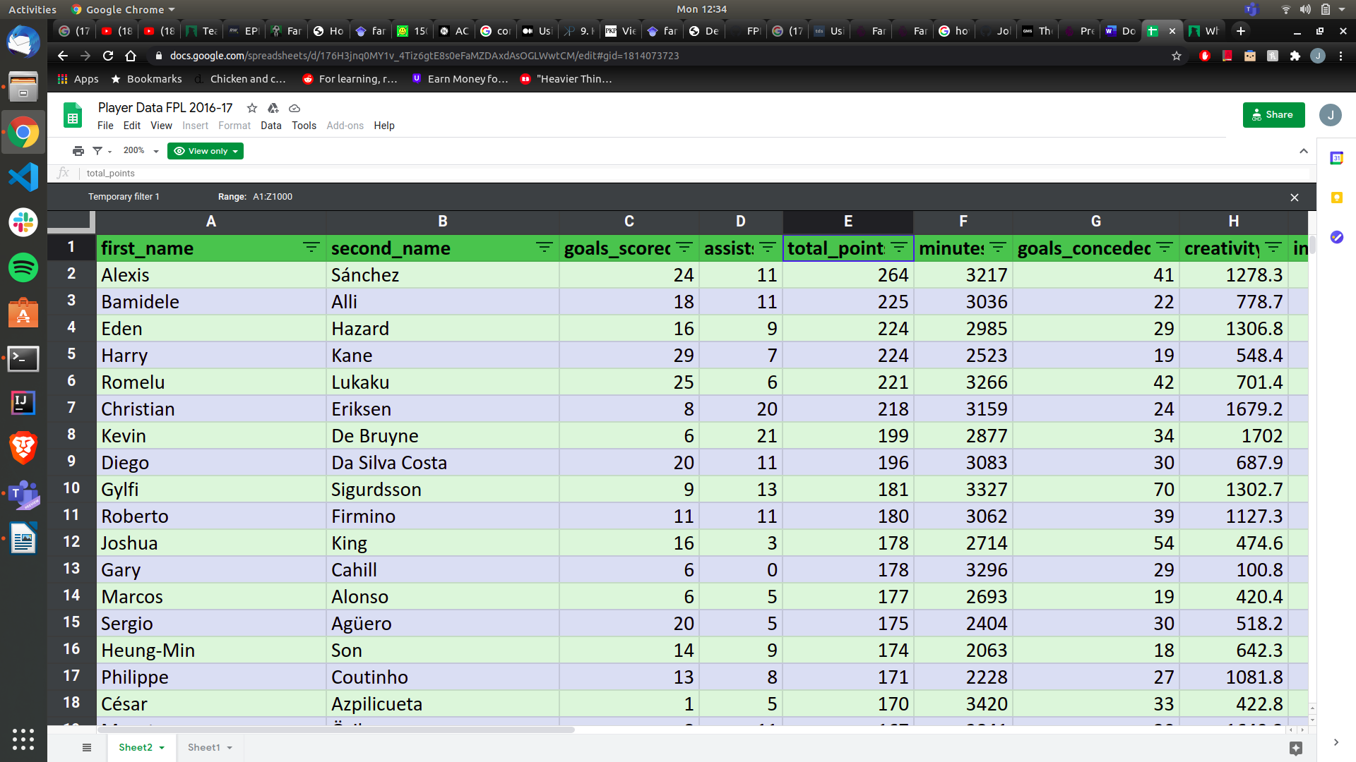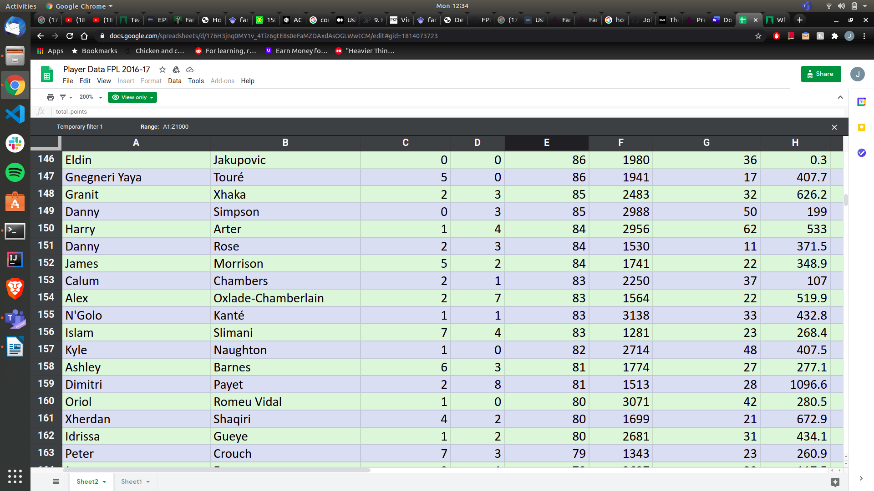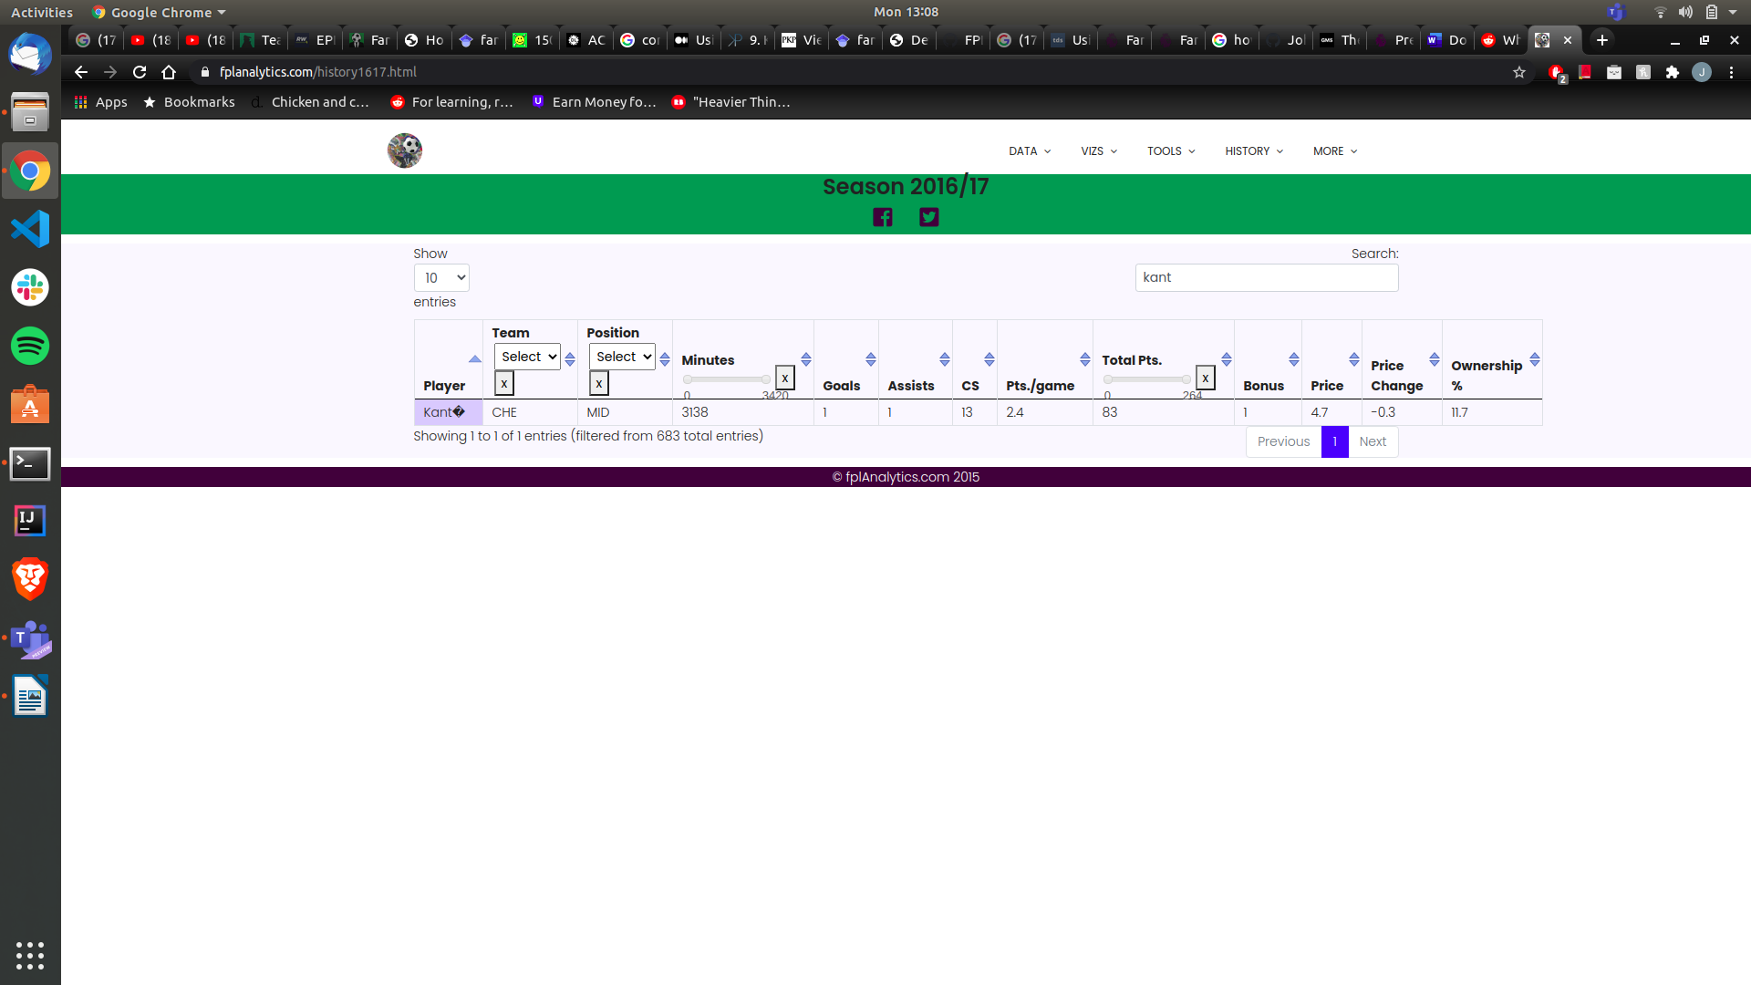Figure 1: 16/17 FPL player season stats [#]

But as these figures show real life ability doesn’t always move over to FPL. The season that Kante won the player of the year award he only came in 156th place for points. A drastic 181 points off the top most points. The main reason for not being a good FPL option is due to his role as a player which is a defensive midfielder. (if point system is mentioned before or after this) a midfielder only gets one point for clean sheets so with this system Kante doesn’t get as many points as the defenders who get 4. So, because Kante doesn’t offer much in the attacking sense of goals and assists and only gets one point for his defensive contribution he is not a good FPL option

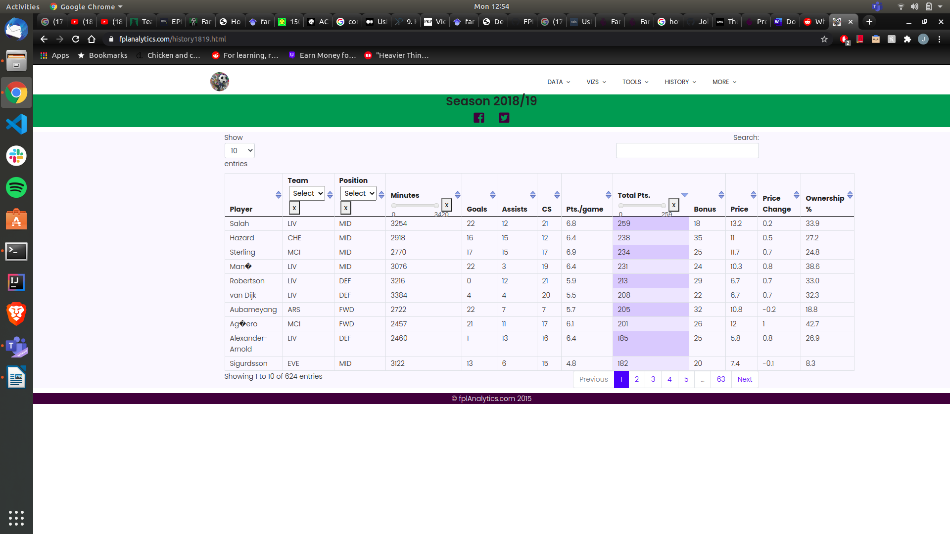Figure 2: 18/19 FPL player seasons stats [#]

Van Dijk suffers a different problem than Kante does. Van Dijk is a highly renounced player and greatly improved Liverpool's defense which resulted in them winning more games [#]. When he is playing Liverpool have a 70.5% win rate and concede an average of 0.94 goals per match. When he isn’t playing however Liverpool have a drastic 42.9% win rate and concede an average of 1.57 goals per match. So without Van Dijk playing Liverpool concede more goals and lose more games. Conceding less goals mean more clean sheet points and if they’re winning more games they have to be scoring more goals. So Van Dijk is fundamental to Liverpool playing well, keeping clean sheets and is highly praised, winning player of the year that season. Even with all of that Van Dijk was still not the highest scoring defender, or even the highest scoring Liverpool defender for that matter. Andy Robertson (Liverpool left-back) has outscored Van Dijk every season for Liverpool as seen below.

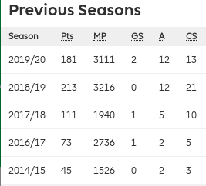 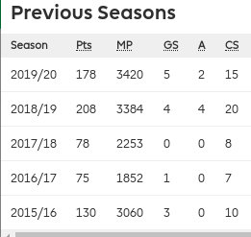

Figure 3 : Robertson vs Van Dijk season stats [FPL website, in transfers]

The main reason for this is because Robertson is a full-back and Van DIjk is a center-back. Center-backs are a traditionally more defensive and full-backs have the ability to be more attacking. Since they have this freedom to go further up the pitch they are more likely to get assists more often. Where center-backs are more likely to get goals from corners (due to their height) but far less often. So in summary a Player shouldn’t be picked solely on their on pitch ability but instead how likely they are to do things that result in point and not losing points.

**Rules and Scoring System**

FPL like any other game has a set of rules that all player have to follow [#]. The following are the ones that involve picking your team as these are the only ones that apply to my prediction algorithm.

Game Rules

* Users have a budget of 100 million to spend on players
* A squad must have 2 Goalkeepers, 5 Defenders, 5 Midfielders and 3 Strikers
* Each week you must pick 11 players to play (1 GK, 3-5 DEF, 2-5 MID, 1-3 FRW) and 4 on the bench
* Can only have 0-3 player from one team in the squad

Scoring System

GK

Clean Sheets : 4 2 Goals Conceded: -1

Penalty Save : 5

3 Shots Saved : 1

Goal : 6

DEF

Clean Sheets : 4 2 Goals Conceded: -1

Goals : 6

MID FWD

Clean Sheets : 1 Goal: 4

Goals : 5

All Players

Playing 0-60 minutes : 1 Penalty Miss : -2

Playing 60-90 minutes : 1 Yellow Card : -1

Assists : 3 Red Card : -3

Own Goals : -2

Bonus Points : Best 3 players in a game get 3,2,1 points

Captain : players total points are multiplied by 2

**The Prediction Algorithm**

When choosing a structure for my algorithm I looked at other peoples attempts at predicting the best FPL team and just general sports prediction algorithms. After searching I narrowed my focus down to two, both showing promising results and both went about the same direction I had in mind for the way I wanted to structure it.

First was a model proposed by Bonomo et al [#]. This model was based off the Argentinian fantasy football (Gran DT) which is “run by a major Argentinian newspaper for the first division of the real Argentinian professional soccer league”. The scoring system and transfer system has the same idea as FPL with a few additions such as points awarded by the newspaper for MOTM. The model worked by averaging the past three weeks points for a player to then predict how many they’d get in the upcoming. This number was then multiplied a number between 1.05 and 0.95 four times depending on the following things: playing at home (x1.05) or away (x0.95, league position (1 to 1.05 if in the bottom five of the table, 0.95 to 1 if in the top five) and a number between 1.05 and 0.95 depending on a scoring streak. Lastly it is multiplied by 1 or 0, 1 if they are expected to play and 0 if not. So if someone has a high expected points but isnt going to start (say because of injury) their points are set to 0 as they won’t play. There is an exception for if they think they will be substituted on they get x1 instead of 0.

Second was a linear/lasso regression approach proposed by William Eilertsen et al [#]. Regression algorithms are common tools in sports prediction but for the purpose of this review I'm going to be looking at the specific one proposed by William. He splits the model into 3 steps: position, variable selection and then fit into a regression model. The variable are the realized points (actual points gained), team, position and home/away. There are then the numerical variables: each weeks previous points, price, transfers in/out, minutes played in each game, yellow/red cards, goals, assists, penalties missed/saved, saves and clean sheets. In the paper they realize that each position gets different points for different things. So therefore they categorize them into each position before continuing with the regression. This is what lasso regression is, by not factoring in for example clean sheets for a striker it gives a more accurate point prediction as it doesn’t matter in a points perspective if a striker’s team doesn’t concede a goal. The model then takes in training data which is done to determine the accuracy and the value of error, this error is then accounted for.

**Constraint satisfaction problem (price and formation)**

PREDICTION ALGORITHM SOURCES

1. <https://onlinelibrary.wiley.com/doi/full/10.1111/itor.12068?saml_referrer>

2. <https://ntnuopen.ntnu.no/ntnu-xmlui/bitstream/handle/11250/2577003/19403_FULLTEXT.pdf?sequence=1&isAllowed=y>

Reading used in algorithm part: (most references for earlier parts are in appendix file, not here)

Medium.com: goes over linear programming. Says to use regression

<https://medium.com/ml-everything/using-python-and-linear-programming-to-optimize-fantasy-football-picks-dc9d1229db81>

Same idea, maybe more tutorial kind of article:

<http://www.philipkalinda.com/ds9.html>

Not a fan but read again:

<https://arxiv.org/pdf/1505.06918.pdf>

Gold: (although used my Kante example :/ )

<https://ntnuopen.ntnu.no/ntnu-xmlui/bitstream/handle/11250/2577003/19403_FULLTEXT.pdf?sequence=1&isAllowed=y>

Still to read properly: (second link is about player streaks of form, 3rd more regression)

<https://ojs.aaai.org/index.php/ICWSM/article/view/3213/3081>

<https://www.sciencedirect.com/science/article/pii/S0305048319302002>

<https://www.sciencedirect.com/science/article/abs/pii/S1469029206000240?via%3Dihub>

Questions I need to ask about

Do they all need to be papers or are articles ok for literature review? I have all articles and websites before “the prediction algorithm” where id then use <https://ntnuopen.ntnu.no/ntnu-xmlui/bitstream/handle/11250/2577003/19403_FULLTEXT.pdf?sequence=1&isAllowed=y>

Could I speak to a statics person from the uni about regression,just to make sure I have the right idea of what it is?

Whats the line of copyright to inspiration with literature review?

Subs

<https://doi.org/10.1080/24748668.2016.11868908>